FCHN -

Functionality
This program creates a list of all check information (prenumbered checks and manual checks) belonging to a paying company code, providing this is sufficient to fulfill the specified selection criteria. The list is sorted according to payment method and check number. Checks voided manually appear at the beginning and checks issued manually at the end of the list.

Scenario
You want to display the data regarding printed checks.

Requirements
Printed checks.

Menu Path | Accounting → Financial Accounting → Accounts Payable → Environment → Check information → Display → FCHN - Check register
Transaction Code | FCHN

1. Double click on FCHN - Check register.

SAP Easy Access

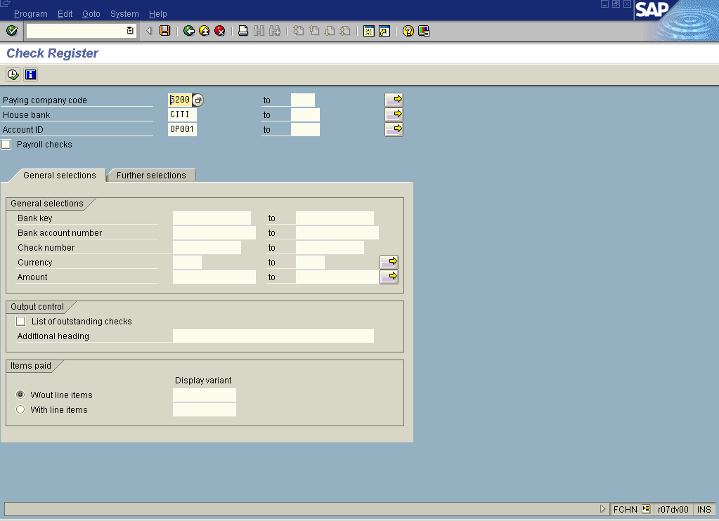

2. Update the following fields:

Field Name | Field Description | Values
Paying company code | Description of the Paying company code. | Example: 5200
House bank | Enter here required bank ID | Example: CITI
Account ID | This ID together with the ID for the house bank uniquely defines a bank account. | Example: OP001

3. Click Enter Button to confirm your entries.

4. Click Execute button to display your report.

Note: The system will display a report that fulfills your criteria. You can export this report to MS Excel or MS Word.

Check Register

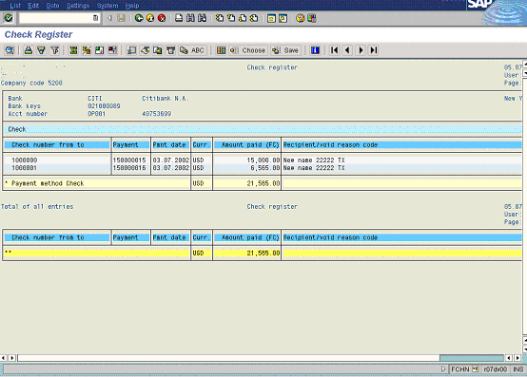

Tip: You can double click on one of the line items to display the details regarding particular check. The system will automatically switch to the transaction FCH1

